*Florida International University*

*School of Computing and Information Sciences*

Software Engineering Focus

Feature Document

User Story ID <NVOS-28 Cross Compare With Other Search Engines>

**Name:** Andrew Castillo

**Team Member(s):** Andrew Castillo, Bryan Bastida

**Project:** EnvoScholar 1.0

**Product Owner(s)**: Mark Finlayson

**Mentor(s)**: Masoud Sadjadi

**Instructor**: Masoud Sadjadi

**User Story Name:** Cross Compare With Other Search Engines

### Description:

As a developer, I want to allow the user to cross compare the results obtained with other search engines, so that they can have access to our articles, the other search engines articles, and determine which articles are better for them

### Acceptance Criteria:

* User entered search query
* Database successfully return articles in display results page
* Buttons for other search engines given the query and applied filtering

**Use Case**

* Name: Cross Compare With Other Search Engines
* Actor: User and webpage
* Preconditions: Articles displayed on webpage as well as the links to other search engine via buttons
* Description <Flow of events>:
  + User types search query and presses search
  + User navigated to display results page with database retrieved articles
  + User presses the links to other search engines on the display results page
  + Sends user to the other search engines site with the applied filter if any.

**Use Case Diagram**

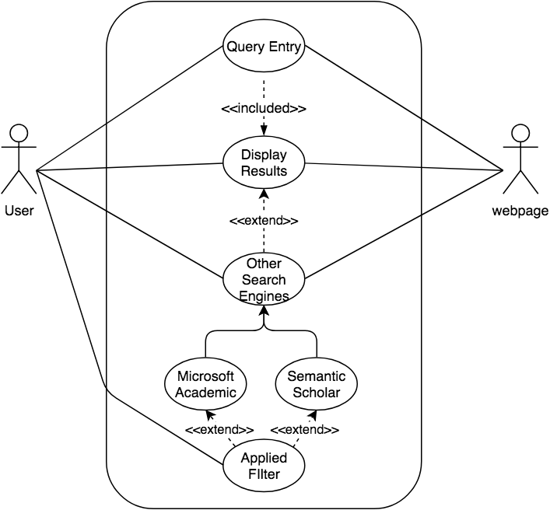

**Sequence Diagram**

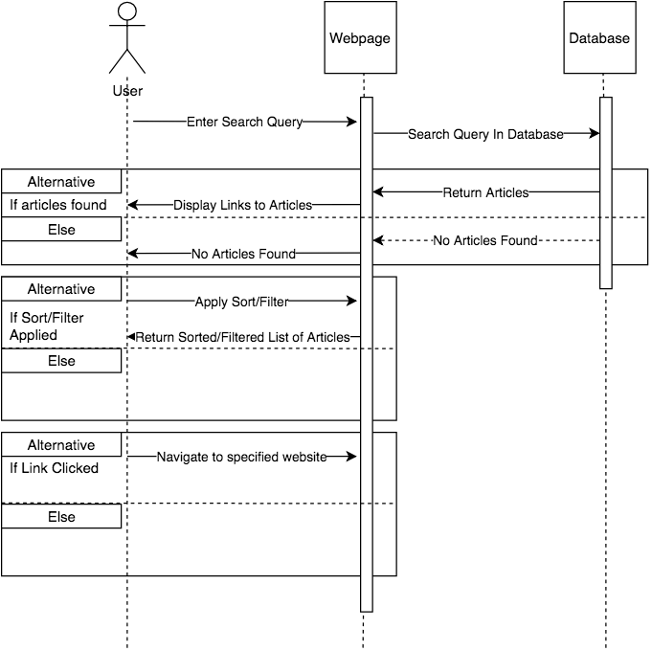

**Class Diagram**

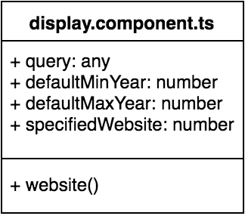

**Unit Test**

* Test case ID: NVOS-28 Cross Compare with Other Search Engines
* Description/Summary of Test: Opens new window to desired website
* Pre-condition: Displayed results list given, filter applied
* Expected Results: Successful navigation to alternate search engine with applied filter
* Actual Result: Successful navigation to alternate search engine with applied filter
* Status (Fail/Pass): Pass

**Visual User Guide**

